**Ideation Phase**

**Define the Problem Statements**

|  |  |
| --- | --- |
| Date | 20 September 2022 |
| Team ID | PNT2022TMID37477 |
| Project Name | Smart Fashion Recommender Application |
| Maximum Marks | 2 Marks |



**Customer Problem Statement**



**s**



**:**

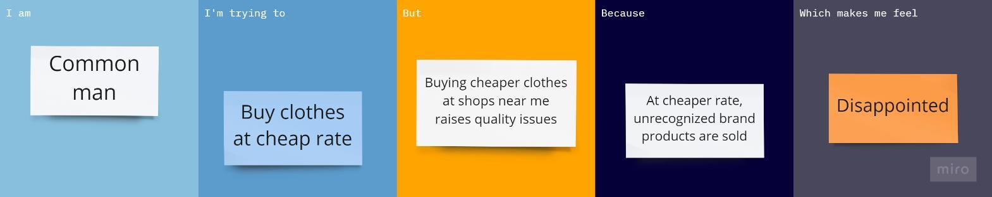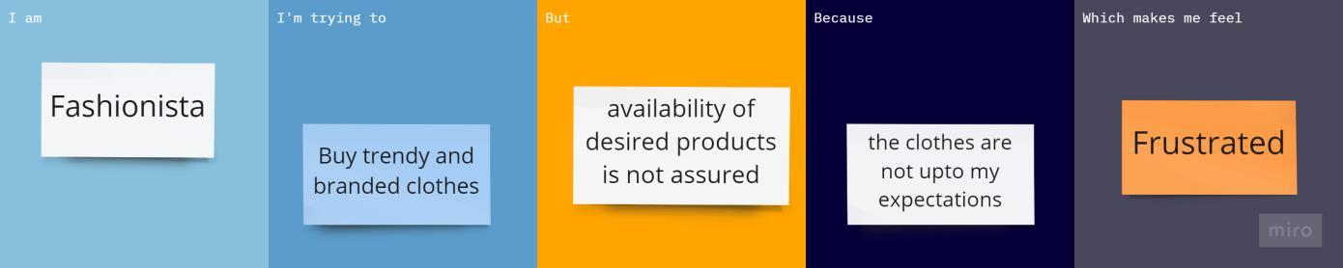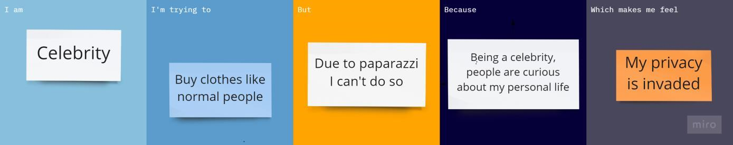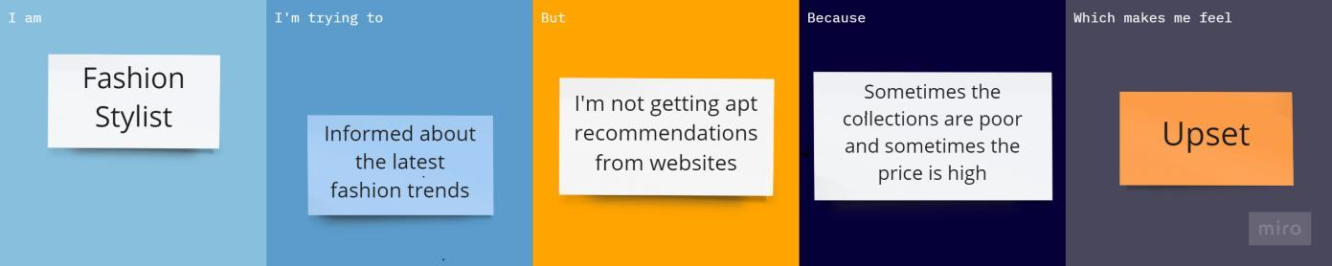

|  |  |  |  |  |  |
| --- | --- | --- | --- | --- | --- |
| **Problem**  **Statement**  **(PS)** | **I am (Customer)** | **I’m trying to** | **But** | **Because** | **Which makes me feel** |
| PS-1 | Common man | Buy clothes at cheap rate | Buying cheaper clothes at shops near me raises quality issues | At cheaper rate,  unrecognized brand  products are sold | Disappointed |
| PS-2 | Fashionista | Buy trendy and  branded clothes | Availability of desired products is not assured | The clothes are not up to my  expectations | Frustrated |
| PS-3 | Celebrity | Buy clothes like normal people | Due to paparazzi, I can't do so | Being a celebrity,  people are  curious about  my personal  life | My privacy is invaded |
| PS-4 | Fashion  Stylist | Informed about the latest fashion trends | I'm not getting apt recommendations from websites | Sometimes the  collections  are poor and sometimes the price is high | Upset |